Become a Volunteer  The Greenfield Fire District is always looking for dedicated and enthusiastic people to join our organization!  Becoming a firefighter or EMT is a rewarding and satisfying way to give back to your community. You get to be part of a team, help out your fellow residents and make a difference in their lives.  Training and Education  After becoming a firefighter in the Greenfield Fire District and going through our orientation program, you will be eligible to participate in various types of training. Your training to be either an Exterior or Interior Firefighter is conducted by NYS certified instructors and is paid for by the District. Tuesday evening drills are scheduled with different types of in-house and annually required refresher training. Depending upon your interests, there are many trainings and courses offered throughout the year, most of which are paid by the Fire District.  Benefits of Joining  In addition to serving your community, receiving no-cost training, GFD offers a Length of Service Awards Program (LOSAP), cancer coverage, Group Accident/Illness, VFBL, Workers Comp coverage. New York State offers a $200.00 tax credit for volunteer firefighters/first responders. |  |  | Stop by one of our firehouses  If you are interested in becoming a member (Firefighter or Auxiliary) of our District, feel free to stop by any of the firehouses on a Tuesday evening after 6:30 pm, which is our weekly drill/training night. You will be able to speak with someone about joining, and they can assist you in completing your application.  The Application Process  Applications are accepted from individuals who reside in our District, or those who reside within a reasonable distance outside our District boundaries. Under NYS law, all firefighter applicants are required to undergo arson and sex offender checks, and the District requires a physical and drug screening by our Medical Provider (paid for by the Fire District) before being accepted into the department.  Equal Opportunity Policy  The Greenfield Fire District does not discriminate on the basis of race, color, national or ethnic origin, religion, sex, age, or marital or parental status in the recruitment and admission of its members, in the admission of its policies and programs, or in the recruitment, appointment or election of its officers, employees or members. |  |  | What it Means to be a Volunteer Firefighter  Greenfield Fire District  Serving the Towns of Greenfield and Wilton since 1947  FOR EMERGENCIES DIAL 911  Contact Us:  District Office Phone: 518-893-0723  Email: Contact@greenfieldfd.org  Website: www.greenfieldfd.org  Facebook: Greenfield Fire District

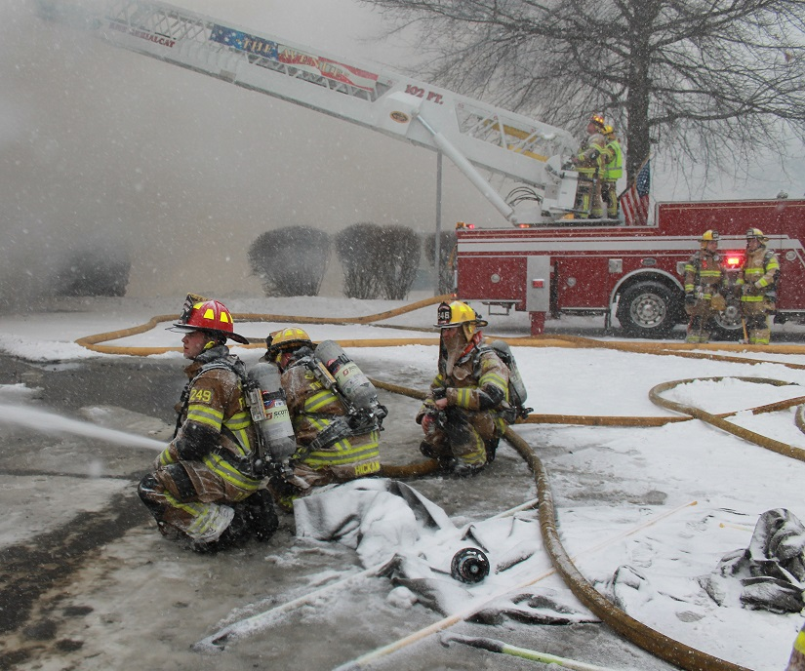  What we Do:  FIRE PROTECTION  Our organization’s primary responsibility is to protect life and property. We respond to a variety of emergencies, including but not limited to: fire alarms, vehicle accidents, extrications, HAZMAT response, emergency medical services, and rescue and disaster responses.  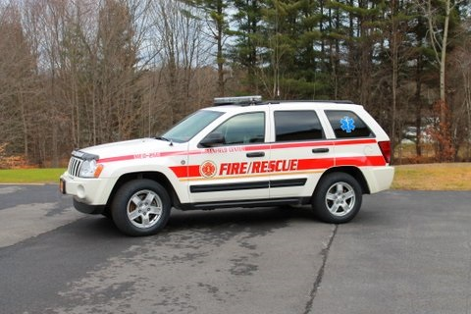  FIRST RESPONDERS  Our EMTs (Emergency Medical Technicians) are often the first to arrive on scene and provide much needed care before the ambulance arrives. All EMT’s receive initial certification and continuing medical training in order to better serve our community.  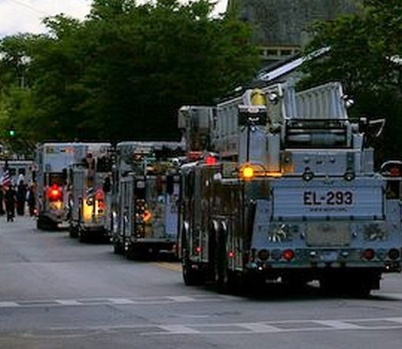  OTHER ACTIVITIES  We are more than just firefighters and EMTs; throughout the year our volunteers can be seen directing traffic (fire police), teaching fire prevention in schools, participating in parades and toy drives. |  |  | 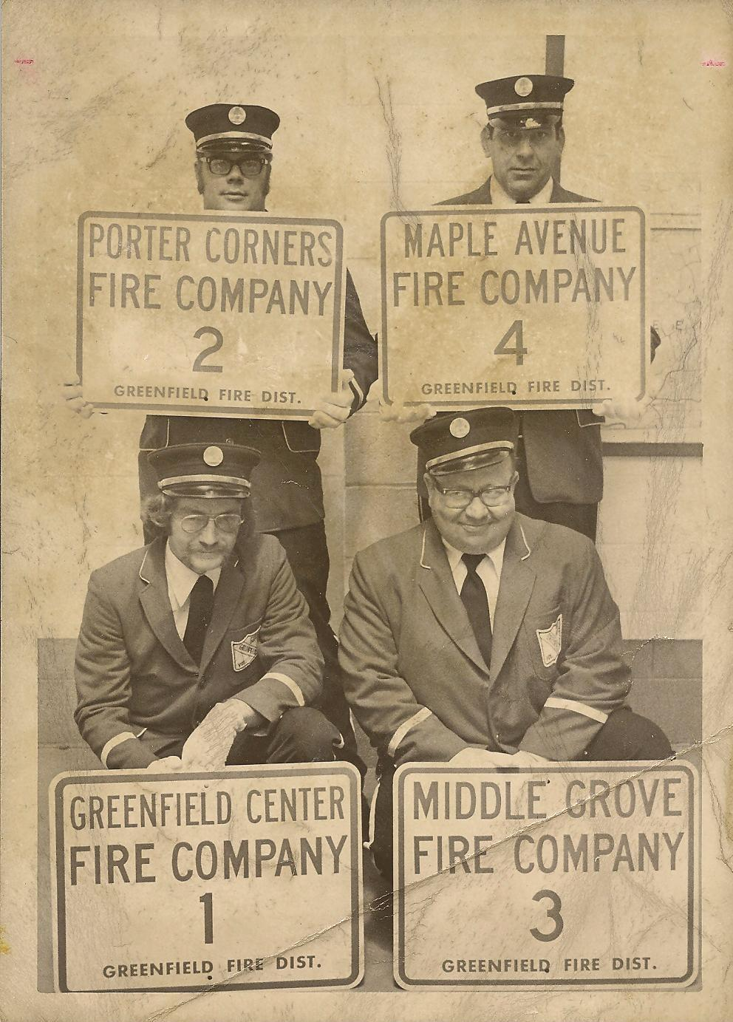  Who are we?  HISTORY  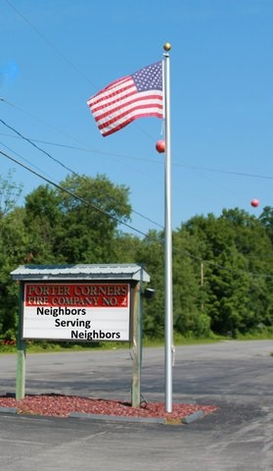  The Greenfield Fire District was formed in 1947 and is governed by a five-member Board of Fire Commissioners. Its original purpose was to provide fire protection to the communities located outside the Saratoga Springs Fire Department response area.  OUR MEMBERS  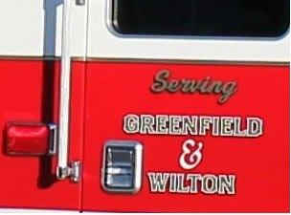  Our members are volunteers dedicated to serving the communities in which they live and work. The Fire District consists of 4 fire companies staffed by your neighbors who provide fire & EMS services to the residents of the Town of Greenfield & the southwest portion of the Town of Wilton. We also have an auxiliary that offers ancillary support to the firefighters.  COVERAGE AREA  The Greenfield Fire District protects over 70 square miles and a population of over 10,000 residents. Our coverage area comprises Greenfield Center, Porter Corners, Middle Grove and the southwest area of Wilton, including the Wilton Mall and the Exit 15 corridor. |  |  | Locations  District Office  13 South Greenfield Rd, Greenfield Center, NY 12833  Non-Emergency Phone # (518) 893-0723  Fire Company #1 (Greenfield Center)  13 South Greenfield Rd, Greenfield Center, NY 12833  Fire Company #2 (Porter Corners)  405 Bockes Rd, Porter Corners, NY 12859  Fire Company #3 (Middle Grove)  25 North Creek Rd. Middle Grove, NY 12850  Fire Company #4 (Maple Ave.)  613 Maple Avenue, Saratoga Springs, NY 12866  FOR EMERGENCIES DIAL 911  FOR NON-EMERGENCY PHONE NUMBERS AND OTHER DISTRICT INFORMATION VISIT OUR WEBSITE: www.greenfieldfd.org or on Facebook: Greenfield Fire District  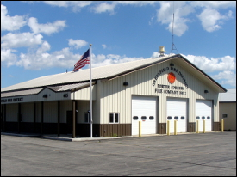  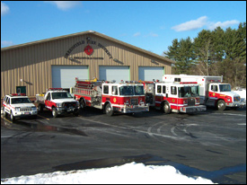  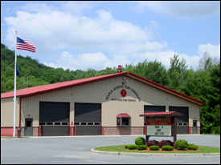  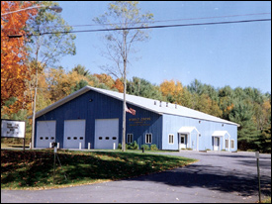  Company #1 Company #2  Company #3 Company #4

